Simulation Based Training: An Essential for the 21st Century Fire Service
Lamb Katherine¹, Waterreus Aaron², Boosman Martijn³,
1. Founder of Effective Command, katherine@effectivecommand.org
2. New Zealand Fire Service, aaronwaterreus@yahoo.com
3. Founder & Director of Business Development at XVR Simulation, Boosman@xvrsim.com

The operational landscape and responsibilities of Fire Services throughout the world have changed dramatically over the last 15 years, with terrorist attacks, extreme weather events and complex fire prevention strategies, all greatly affecting the scope, severity and importantly numbers of the incidents attended. This dynamic operating landscape requires the Fire Service throughout the world to constantly change, adapt and innovate in order to stay relevant and up to date. In light of efficiency savings, smaller numbers of resources and additional non-operational responsibilities, there is a demand for efficient and effective operational training to allow the personnel to train for the ‘unexpected’. This paper investigates how three very different International Fire Services are utilising simulation based training to tackle this problem from three very distinct demographics, namely Singapore, the United Kingdom and New Zealand.
Over the last decade the number of operational incidents responded to, by the UK Fire and Rescue Service alone has diminished by 40% (Knight, 2013). This reduction in incident number and consequential reduction in experiential learning opportunities has resulted in a deterioration of incident evaluation skills by the Fire Service commanders. With this reduction in incident numbers mirrored around the world and the consequential reduction in experiential learning opportunities, simulation and virtual reality (VR) are realistic and cost effective ways to build and maintain operational command and control skills in officers.
Fire Service training methods, have traditionally incorporated large amounts of lecture or classroom-based tuition. The individuals then use this technical knowledge and develop operational competence, through practical application, utilising traditional drill sessions and incidents. More recently many Fire Services are turning to simulation as an alternative training tool to provide this essential, application-based, incident or scenario exposure.
Competence or expert knowledge can be differentiated into two distinct groups, explicit knowledge and tacit knowledge. Explicit knowledge is factually based, and traditionally taught in a classroom, but is proven of little use in generating effective skill-based training. An individual can learn the technical aspects of fire behaviour, including flashover or backdraught conditions, but it is unlikely that they would generate any practical competence from this form of training.
Whereas, tacit knowledge involves a detailed understanding of how a whole system operates. It is the use of the explicit technical knowledge through practical application that translates it to tacit knowledge or operational competence. Individuals need to see, hear and feel during practical training sessions, simulation-based scenarios or at actual incidents, before the technical knowledge they learnt in the classroom, begins to make sense. This harmony of explicit (technical) and tacit (practical ability) knowledge allows these two key pieces of the training puzzle to fit together, resulting in a state of operational competence in the individual (figure 1).
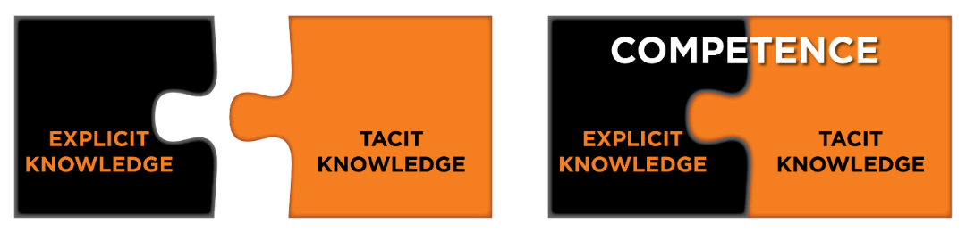
Figure 1 –Diagram illustrating the important interaction between Explicit and Tacit knowledge and training, during the attainment and maintenance of the competent state
Simulation can be used to replicate the pressure of the incident ground with none of the associated incident ground risk. The individual is immersed through high quality graphics, realistic and believable environments, and importantly reactive scenarios that change according to the actions detailed by the officers or crews. Role players are also a vital component of both simulation and VR scenarios, as they provide key information to assist the officer with prioritisation and decision making.
XVR simulation software is currently used (or implemented in the near future) by all three services studied, and is a flexible training and competence assessment tool. XVR software is used by over 200 emergency services worldwide and its versatility supports a variety of uses with the training domain. This enables the instructors to create scenarios that are bespoke to their geographical or topographical area, recreate specific incidents for training issues or debriefs and to develop an array of different incident types and training tools.
XVR enables the individual or a group of individuals to operate within the scenario, as a specific role or as a command team (Figure 2). They can also request actions to occur during the resolution of the incident; these actions are then completed dynamically by the instructor. This functionality of the software aids the individual’s immersion into the scenario, and the quality and accuracy of the graphics enable the individual to make operational decisions about the use of the equipment and resources they see on the screen. There is also the ability to change the weather, the wind direction, and the time of day of the scenario. These details improve the individual’s immersion into the scenario and provides the most realistic environment available, enabling them to demonstrate their competence, and their ability to make appropriate dynamic decisions, as an alternative to incident exposure.
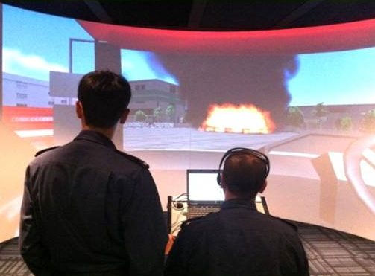 | 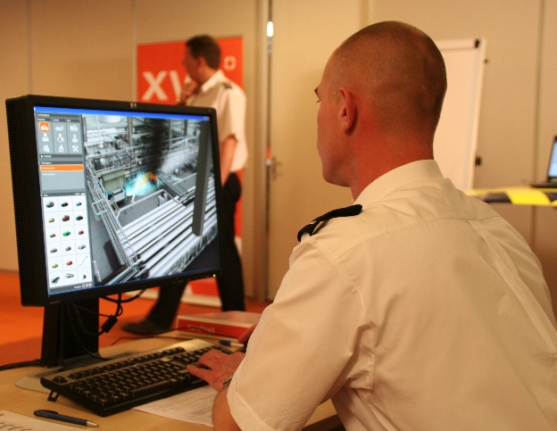
Figure 2 – Simulation in use during training, ACTS in Singapore (left), XVR (right).

Singapore is preparing to utilise XVR within their second generation Advanced Command Training System (ACTS2) for better training of Singapore Civil Defence Force’s (SCDF) frontline commanders, during incident command and control. The current ACTS system helps to bridge training gaps between classroom and in-field training in particular the limitations posed by table-top and in-field exercises. Table-top exercises lack realism whereas realistic in- field exercises are not practical in Singapore due to the lack of space, ability to obtain resources (motor vehicles, for example, are at a premium in Singapore and difficult to obtain for RTA training) and safety constraints. Training scenarios that are complex or difficult to simulate with conventional training facilities, can be created in ACTS with ease. ACTS is a more cost effective method to simulate realistic incidents of differing scale and complexity and can incorporate realistic challenges commanders face on the incident ground such as firefighter fatigue and unreliable or over run water supplies. ACTS 2 is a further enhancement of ACTS providing a greater range of scenarios, using improved graphics and the greater functionality that XVR provides.
In the United Kingdom, XVR simulation software is generally used during critical decision making training, and the assessment of command competence, with many services using the Introspect Assessment Model (Lamb et al., 2014). XVR provides a reactive visual stimulus that can be manipulated by the instructors, to reflect the actions and decisions detailed by the commander. The Introspect Model investigates the rationale that sits behind these command decisions, and gives confidence to individuals who have successfully transferred their explicit incident command knowledge to tacit knowledge, and ultimately competence, within the safe environment of simulation.
New Zealand has been using simulation and VR training for a number of years, and has traditionally focussed on the “outcome” of scenarios rather than the “process” of incident management. The team trainer platform has been popular where several sector commanders operate and report to the incident controller. Traditionally this involved a limited number of fixed scenarios, however, the recent shift to XVR enables the creation and use of dynamic training scenarios which provide the individuals the opportunity to practise critical decision making under pressure. New Zealand has started a process of including local risks incorporated with simulated fire conditions, to train and assess commanders on their information gathering, risk assessment and initial action decision making. The intention is to use XVR and its range of functionality to take these training principles further, to include all incident management skills and classroom based team training, to demonstrate best practise or procedure.
The 21st century Fire Service utilises a combination of tools from the ‘training toolkit’ recognising each for its merits and limitations. Real life practical training and virtual reality simulation like XVR will continue to be used in parallel, or integrated during hybrid training of fire officers and other incident responders. They are complementary disciplines that each offer distinct benefits for training specific skills and capabilities. XVR delivers the flexibility for the instructor to design, provide and implement varied, realistic, and importantly reactive training scenarios. These advantages have been recognised in Singapore, New Zealand and the United Kingdom, who utilise this ‘state of the art’ training tool to provide their commanders limitless opportunities to transfer their explicit knowledge into tacit knowledge, and ultimately competence.
References
- Knight K., (2013). “FACING THE FUTURE: Findings from the review of efficiencies and operations in fire and rescue authorities in England”, available at: https://www.gov.uk/government/uploads/system/uploads/attachment_data/file/200092/FINAL_Facing_the_Future__3_md.pdf, (accessed 09/07/2015).
- Lamb, K. J., Davies, J., Bowley, R., and Williams, J-P. (2014). “Incident command training: the introspect model”. International Journal of Emergency Services, Vol. 3, No 2, pp131-143.

